Usecase Diagram
Please search for following keywords in MS Visio for symbols.
user - Actor
use case - use case
include - include
extend - extend

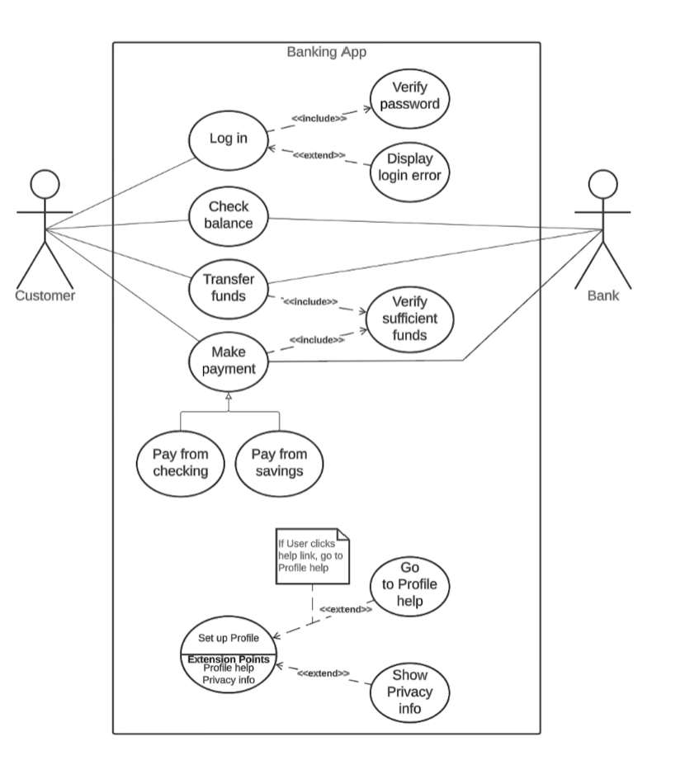
Note : Use-Case Narrative. Chapter 6 – Slide 22

Class Diagram
Class diagram symbols can be found in MS Visio as follows.
Class - Class
Association - Use a regular line
Aggregation - aggregation
Composition - composition
Multiplicity - use a text box

Example:


